**Lab Assignment – 1**

**Name**: Arun Anthati **Course**: ASE

**Student ID**: 16232818  **Lab No**: 1

**Class ID**: 62 **Date**: 9th Dec,2016

**Objective :**

The main aim of this assignment is to provide an overview about class diagram which is one of the representation in UML diagrams for software architecture. This is important as software architecture is the blueprint for the system, it allows reasoning about performance, availability, and other attributes, allows planning for incremental development, and guides work assignments and tracking. Also to get an idea about GitHub, how to share code between different members in a team using Git, how to create iterations and issues for a project, creating wiki pages to a project through Git.

**Class diagram for chat application:**

**Scenario:** A user can create an account and add friends using their mobile number or email id. User can chat with any individual from his friends list, User can also create groups and invite his friends to join the group. In addition to that, media like images, video, location can be shared with friends and group.

**Solution:**

Below class diagram is drawn with the help of creately tool. In this, every account is linked with each user. Without account being created, user do not have any option to chat, create groups, send images or videos or location. So user and account are in composite relation with each other. Once the account is successfully set up, then user has access to send invite to his/her friends to chat. Also a valid user can create multiple groups or no groups at all to chat and similarly can chat with any of their friends or with no one.

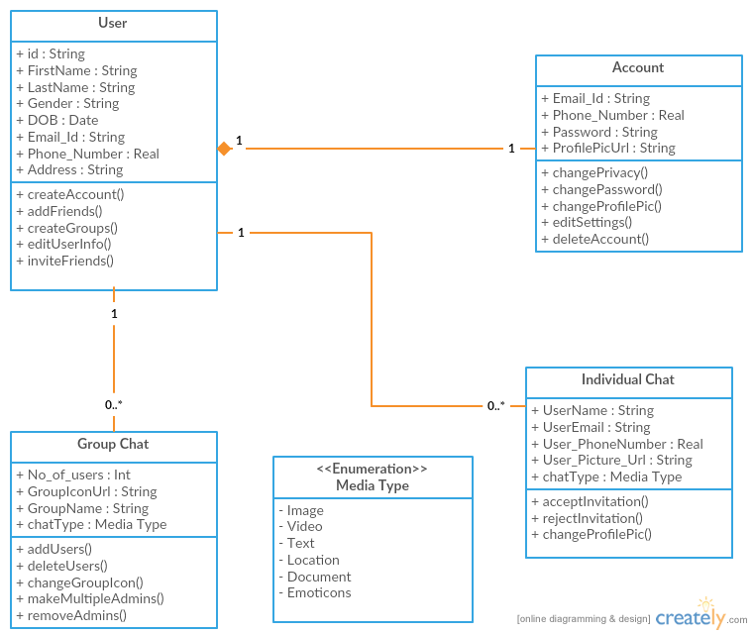

**Create a board, 3 iterations, at least 5 tasks and show the analytics graph:**

**Description:**

In this three different iterations are created with each iteration having five unique issues and the burndown charts are given below

**Iteration – 1**

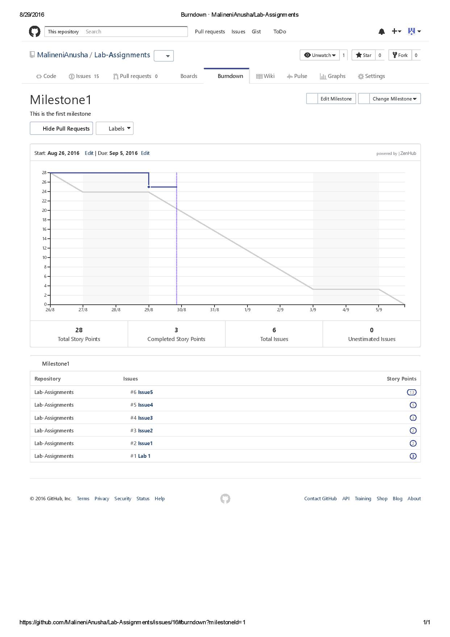

**Iteration – 2**

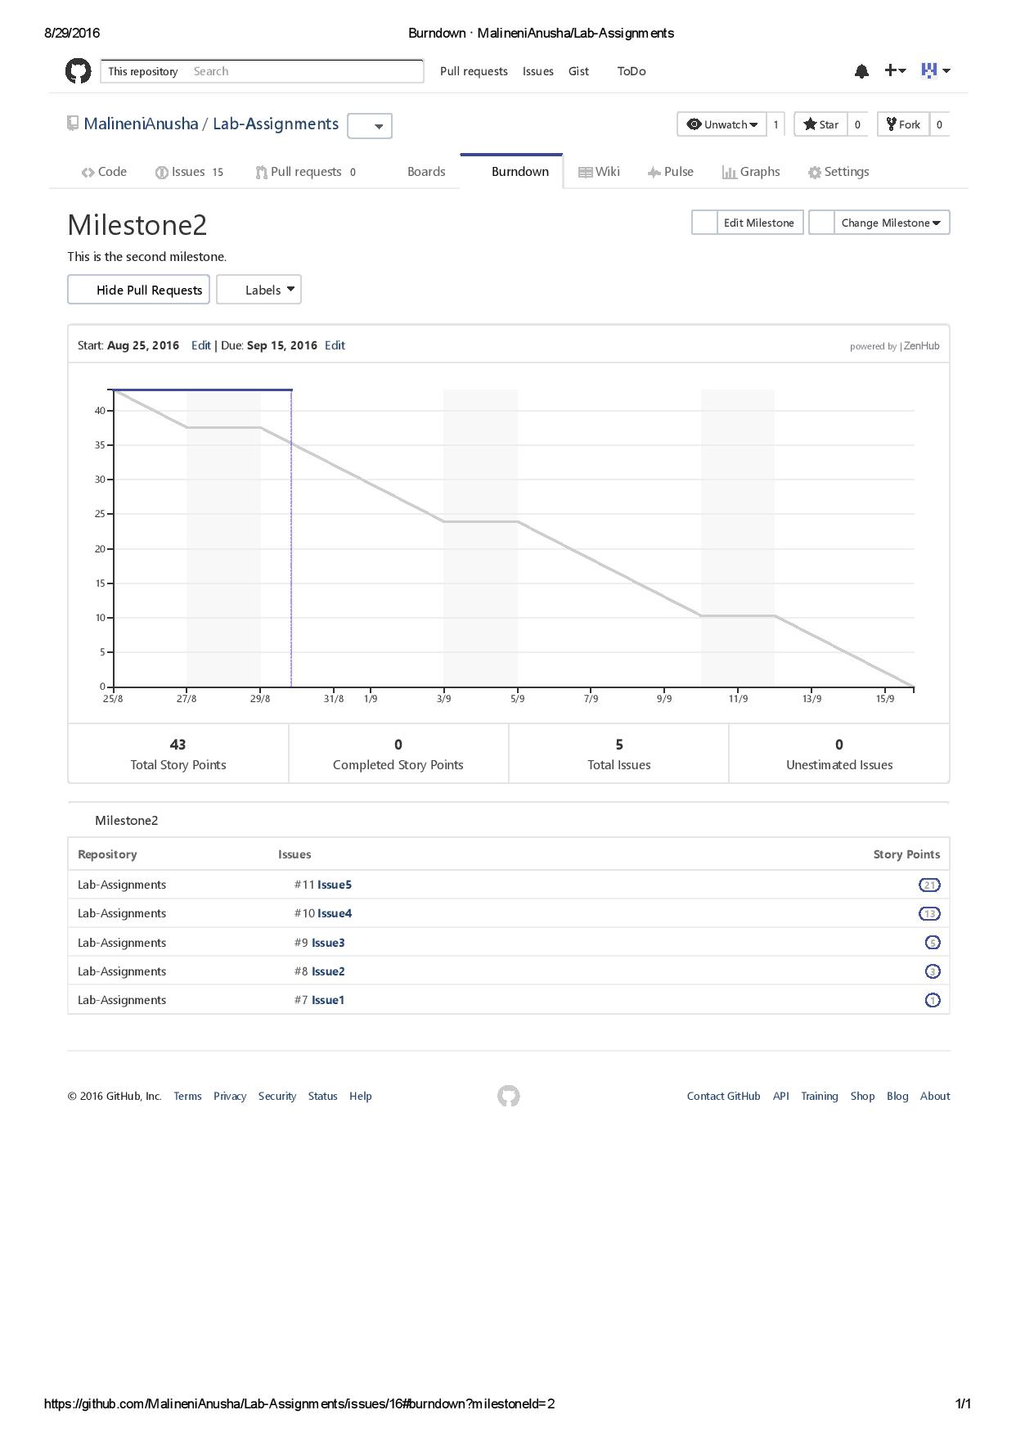

**Iteration – 3**

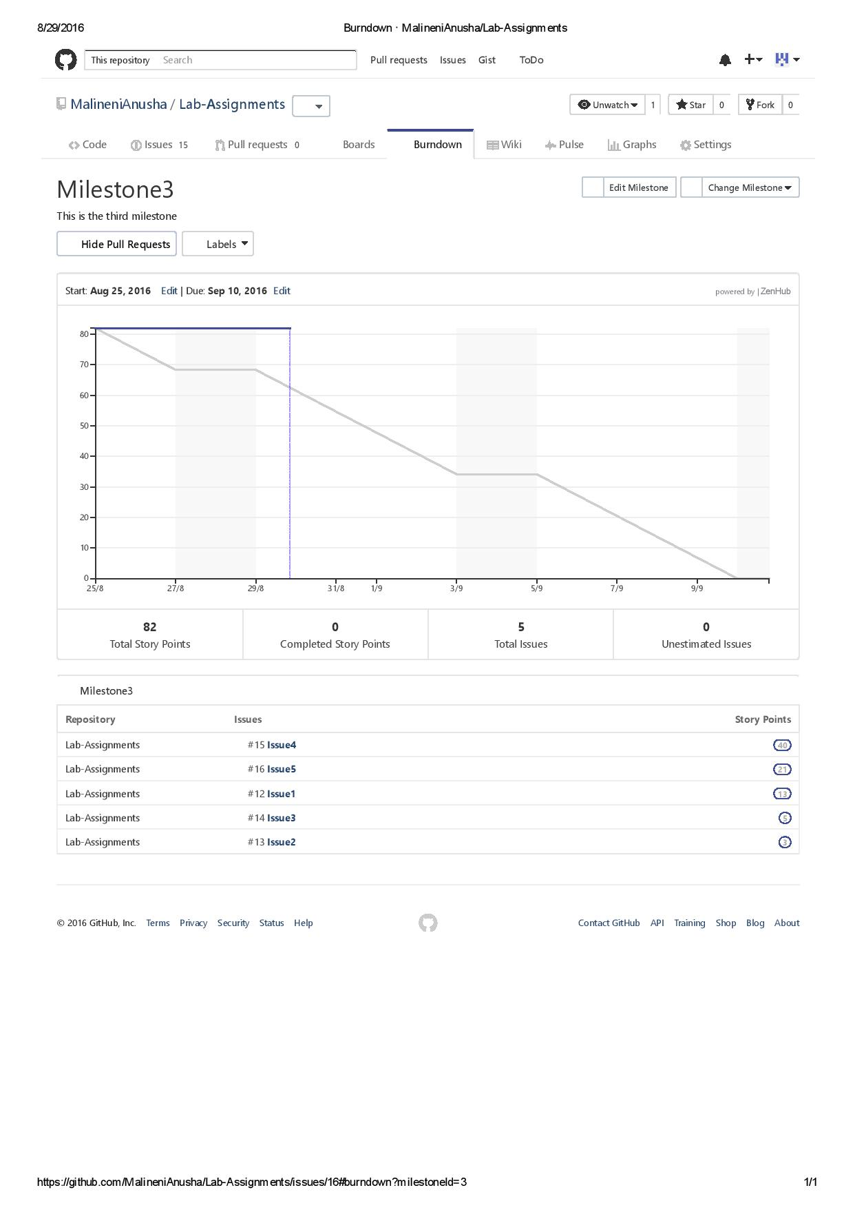

**Create a wiki page through Github:**

**Description:**

A sample wiki page is created in Github. Wiki page mainly helps to describe the work done by user.

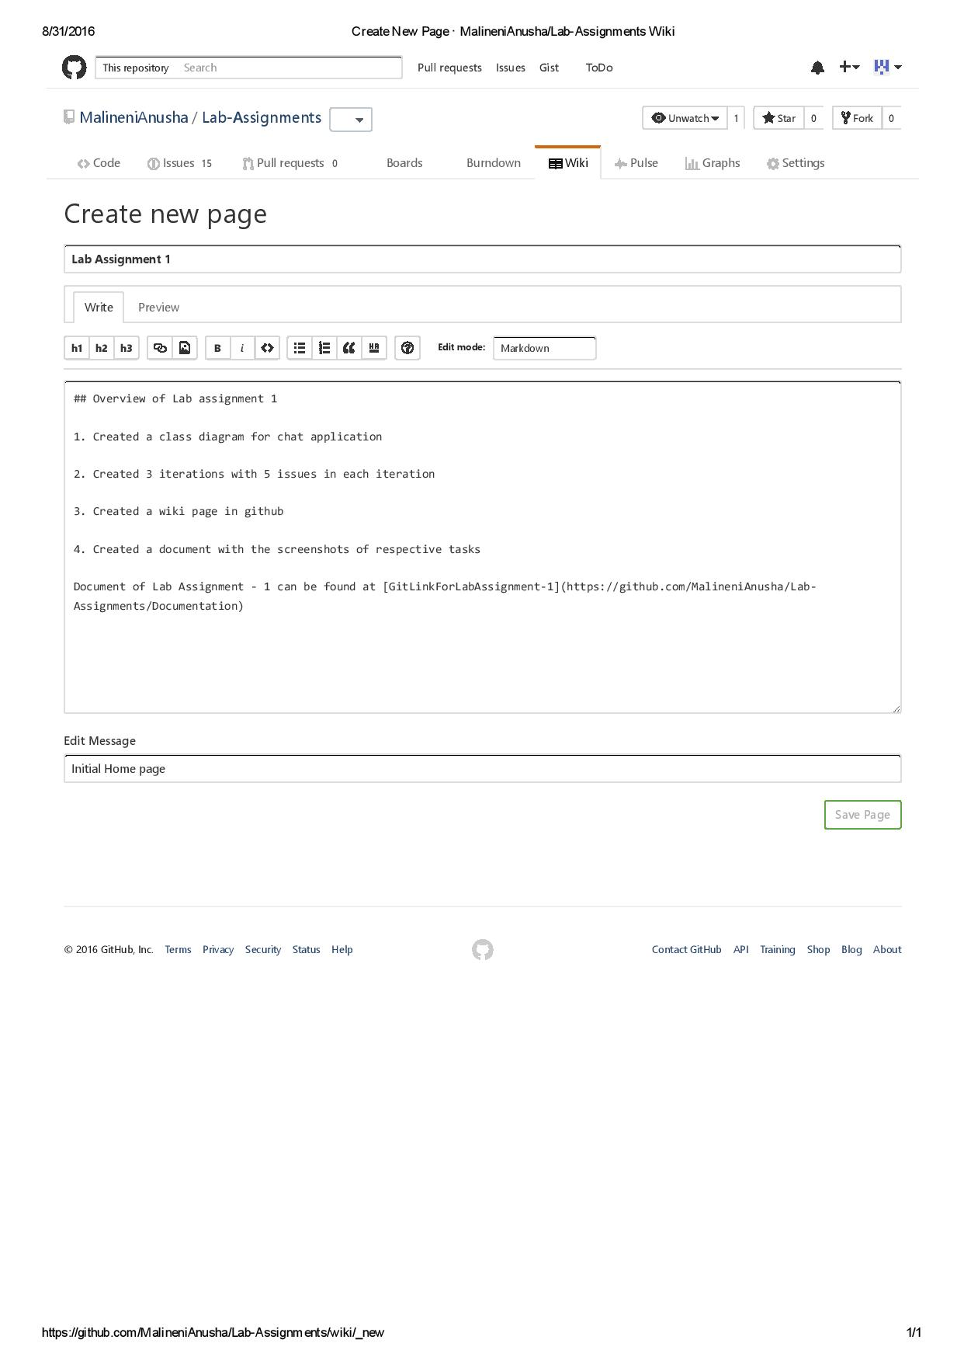

**References:**

1. <https://creately.com/>
2. <https://github.com/>